**VISVESVARAYA TECHNOLOGICAL UNIVERSITY**

**“JnanaSangama”, Belgaum -590014, Karnataka.**



**PROJECT WORK-1 REPORT**

**on**

**B.M.S. COLLEGE OF ENGINEERING**

**EVENT PAGE**

***Submitted by***

**AAKANKSHA GUPTA (1BM19CS001)**

**BHARATH MAHESH GERA (1BM19CS035)**

**BHAVYA SINGH (1BM19CS037)**

**DHRUV DUBEY (1BM19CS048)**

***Under the Guidance of***

|  |
| --- |
| **REKHA G S**  **Assistant Professor, BMSCE** |

***in partial fulfillment for the award of the degree of***

**BACHELOR OF ENGINEERING**

***in***

**COMPUTER SCIENCE AND ENGINEERING**



**B.M.S. COLLEGE OF ENGINEERING**

**(Autonomous Institution under VTU)**

**BENGALURU-560019**

**Sep-2020 to Jan-2021**

**B. M. S. College of Engineering,**

**Bull Temple Road, Bangalore 560019**

(Affiliated To Visvesvaraya Technological University, Belgaum)

**Department of Computer Science and Engineering**



**CERTIFICATE**

This is to certify that the project work entitled “**B.M.S. COLLEGE OF ENGINEERING EVENT PAGE**” carried out by **AAKANKSHA GUPTA (1BM19CS001), BHARATH MAHESH GERA (1BM19CS035), BHAVYA SINGH (1BM19CS037) AND DHRUV DUBEY (1BM19CS048)** who are bonafide students of **B. M. S. College of Engineering.** It is in partial fulfillment for the award of **Bachelor of Engineering in Computer Science and Engineering** of the Visvesvaraya Technological University, Belgaum during the year 2020-2021. The project report has been approved as it satisfies the academic requirements in respect of **Project Work-1 (19CS3PWPW1)** work prescribed for the said degree.

Signature of the Guide                 Signature of the HOD

REKHA G S Dr. Umadevi V

Assistant Professor Associate Prof.& Head, Dept. of CSE

BMSCE, Bengaluru BMSCE, Bengaluru

External Viva

Name of the Examiner                                                                                       Signature with date

1._____________________________ ________________________

2. _____________________________ _________________________

**B.M.S. College of EngineerinG**

**DEPARTMENT OF COMPUTER SCIENCE AND ENGINEERING**



***DECALARATION***

We, AAKANKSHA GUPTA (1BM19CS001), BHARATH MAHESH GERA (1BM19CS035), BHAVYA SINGH (1BM19CS037) and DHRUV DUBEY (1BM19CS048), students of 3rd Semester, B.E. Department of Computer Science and Engineering, B. M. S. College of Engineering, Bangalore, hereby declare that, this Project Work-1entitled "B. M. S. College of Engineering Event Page" has been carried out by us under the guidance of REKHA G S, Assistant Professor, Department of CSE, B. M. S. College of Engineering, Bangalore during the academic semester Sep-2020-Jan-2021

We also declare that to the best of our knowledge and belief, the development reported here is not from part of any other report by any other students.

Signature

AAKANKSHA GUPTA (1BM19CS001)

BHARATH MAHESH GERA (1BM19CS035)

BHAVYA SINGH (1BM19CS037)

DHRUV DUBEY (1BM19CS048)

1. Introduction

Website development for “B. M. S. College of Engineering Event Page”

This online submission system supports only Students

**Functionalities for Student login**

i. Students can explore events happening in college

ii. Students can register for events

2. Design Layouts: Screen Shots of Webpages

2.1: Login Webpage

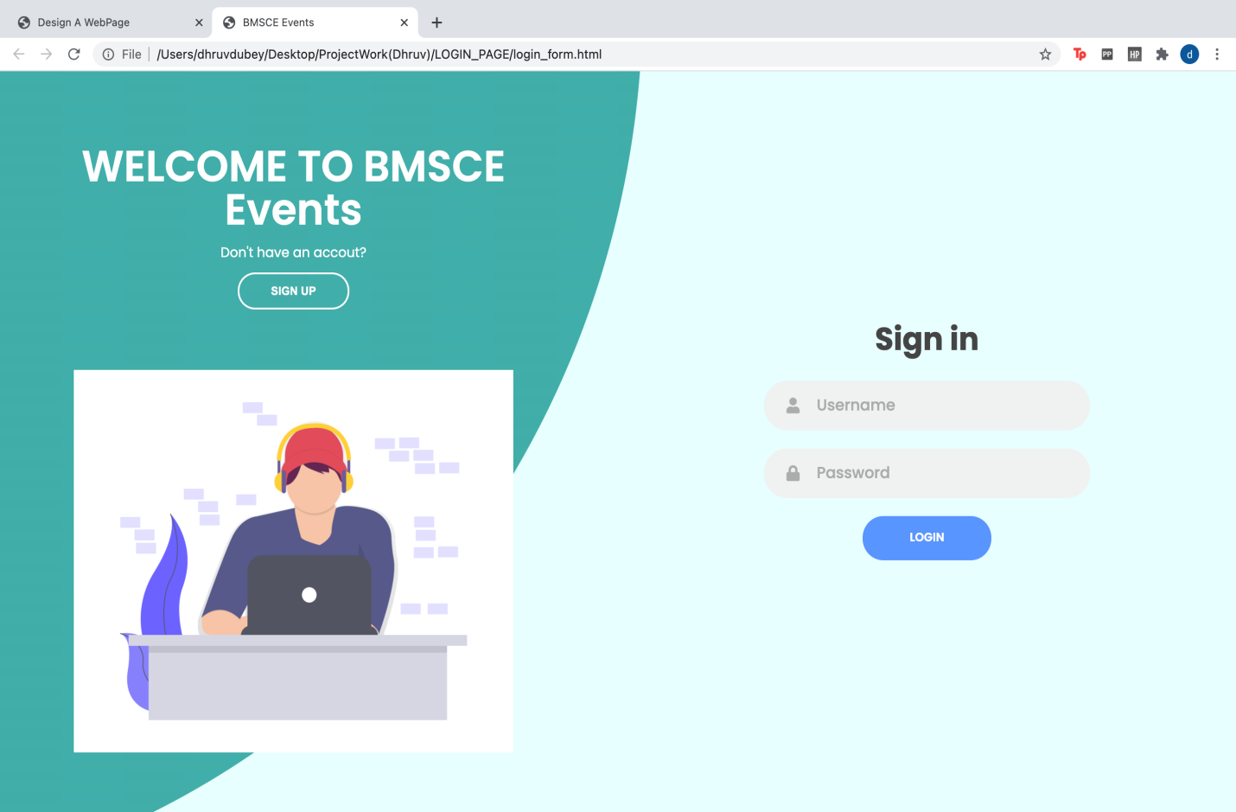

2.2: Sign-up Webpage



2.3: Home Webpage

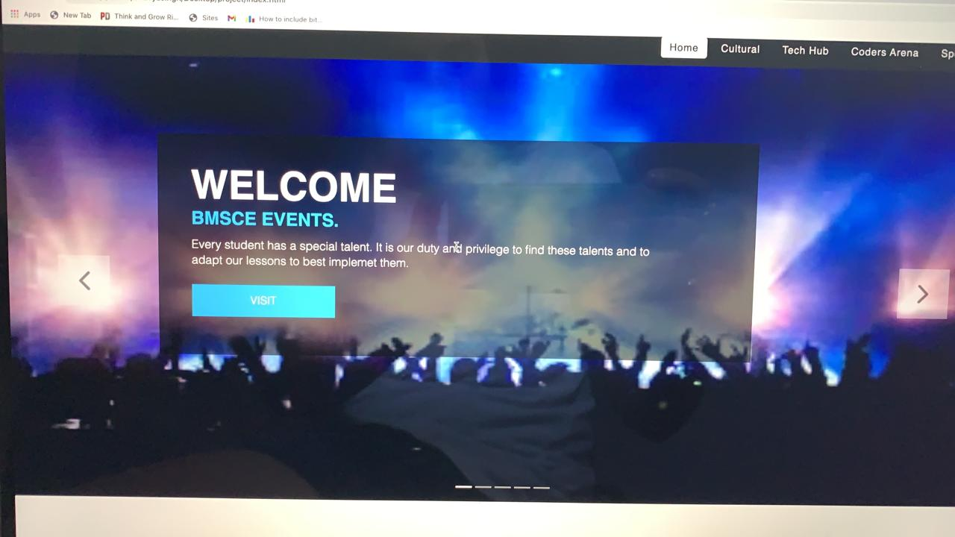

2.4.1 : Cultural Home Webpage

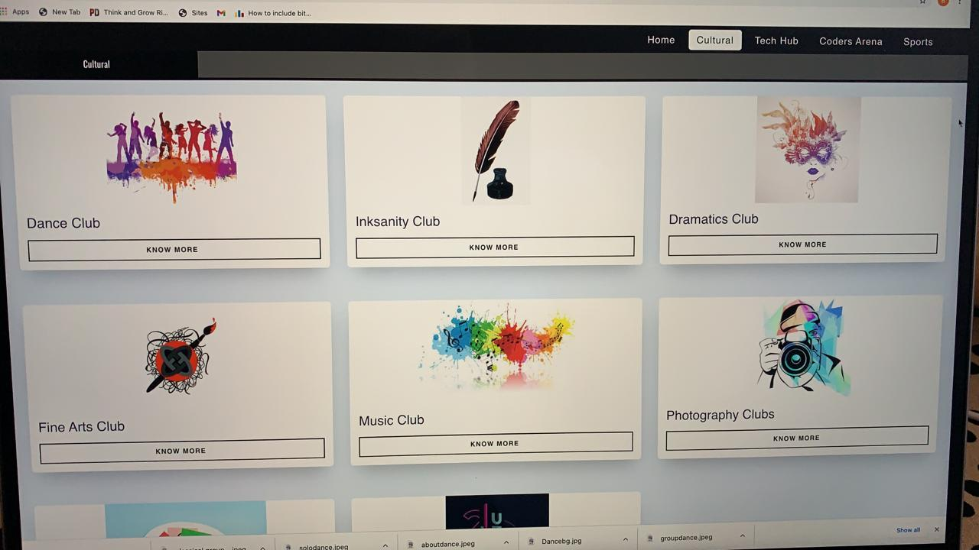

2.4.2: Cultural Information Webpage

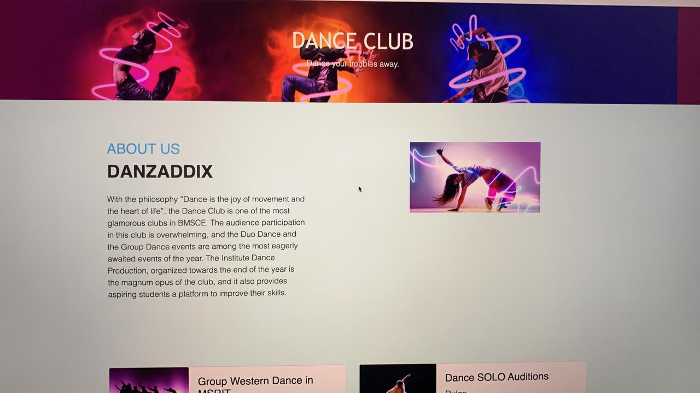

2.5.1 : Tech Hub Home Webpage



2.5.2 : Tech Hub Information Webpage

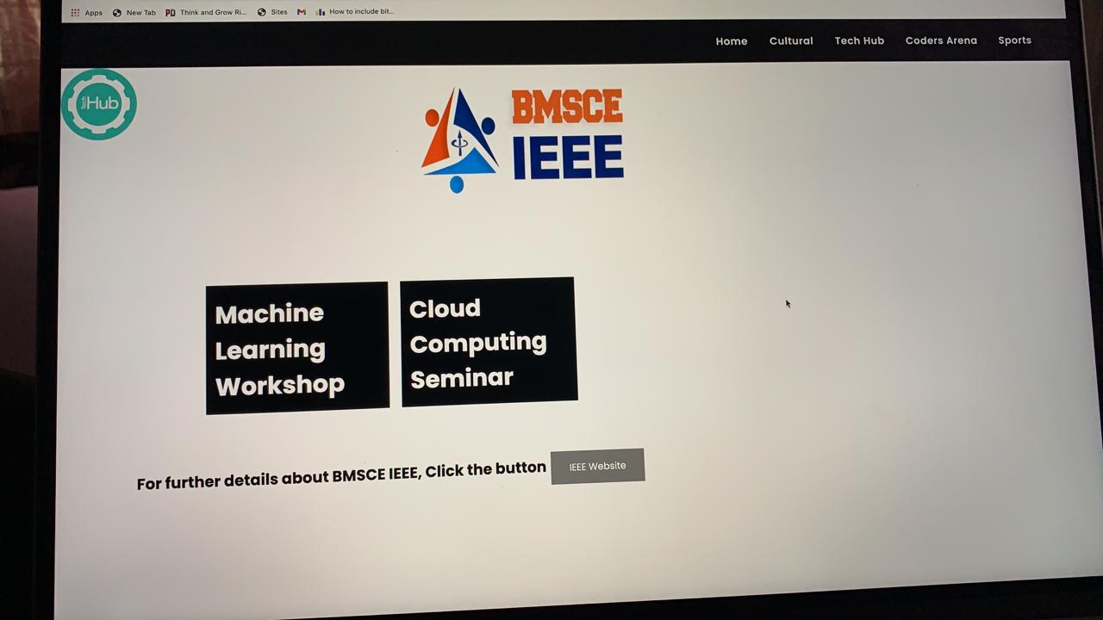

2.6.1: Coder’s Arena Home Webpage

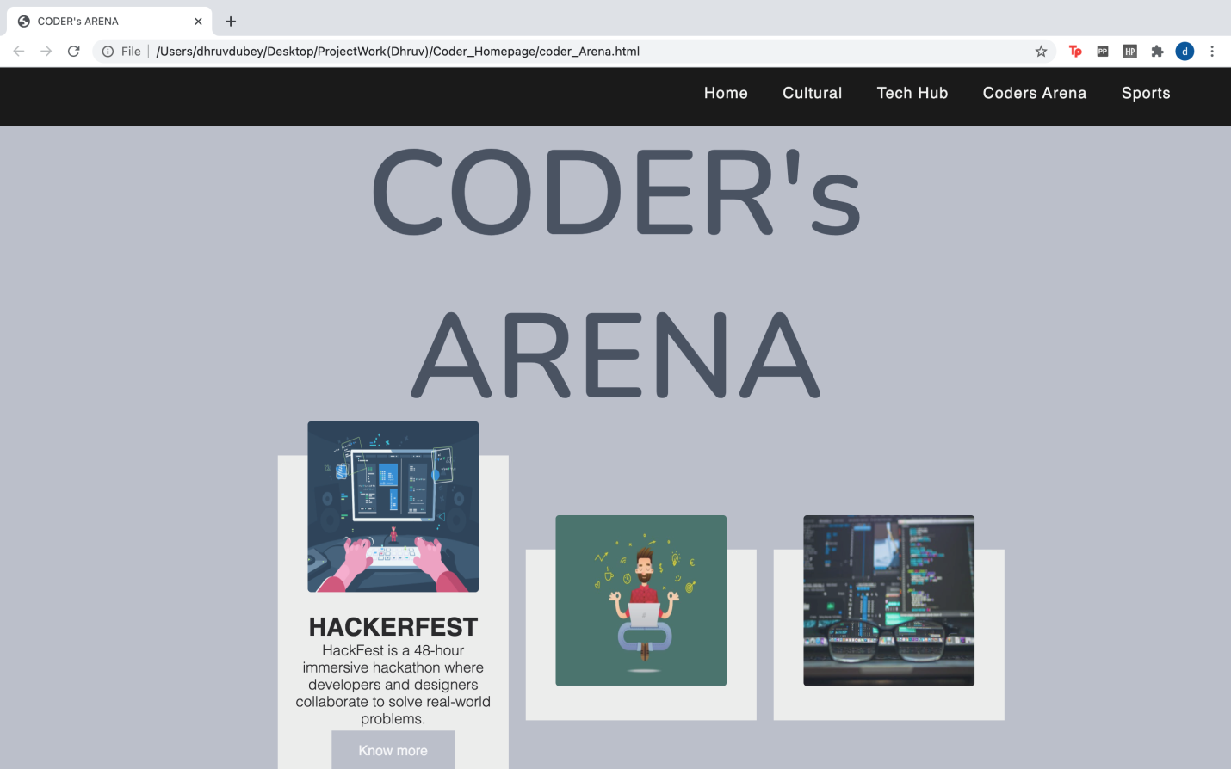

2.6.2 : Coder's Arena Information Webpage

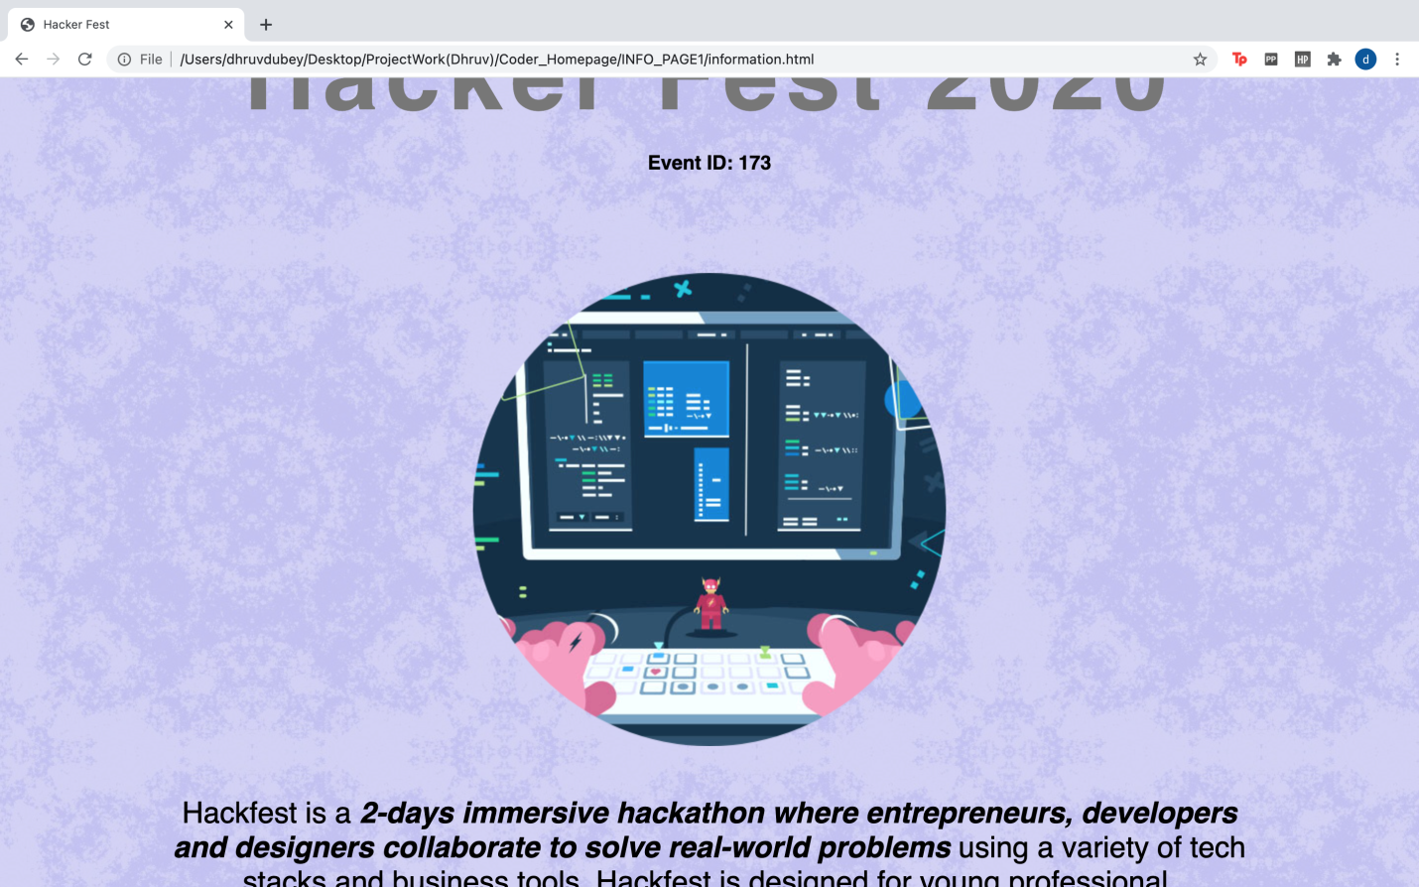

2.7.1 : Sports Home Webpage

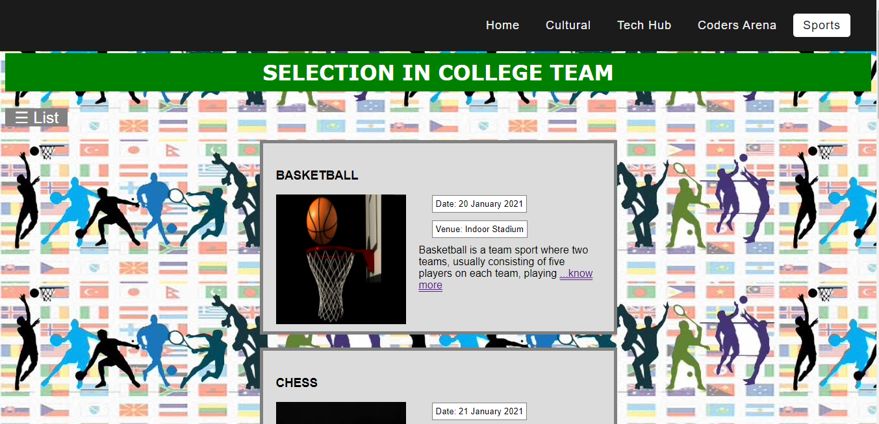

2.7.2: Sports Information Webpage

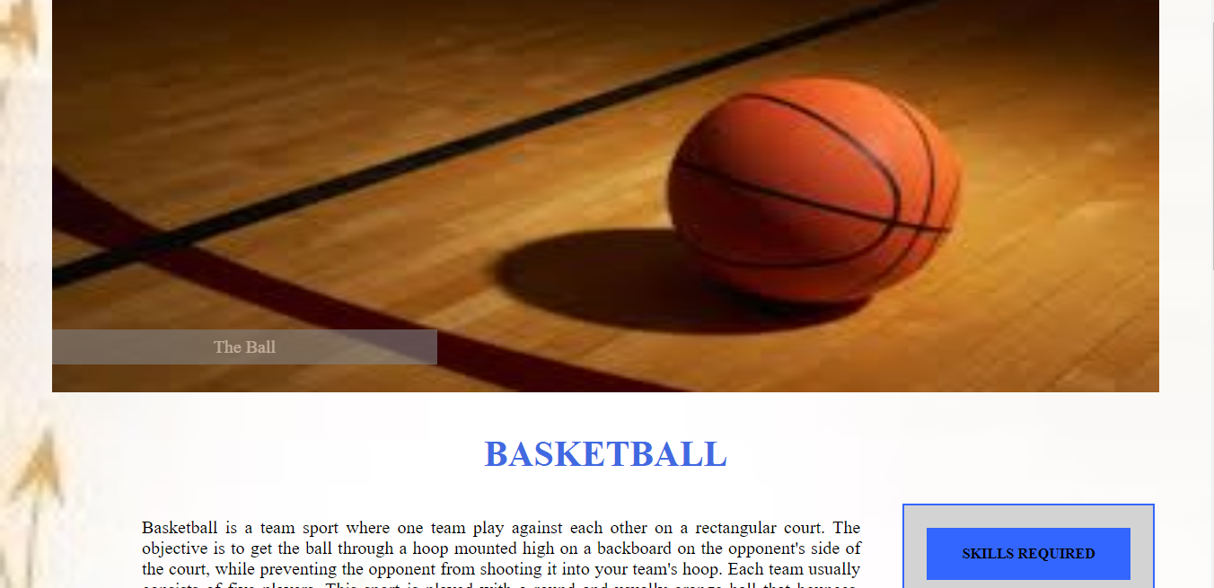

2.8: Register Page

